Media Contact: Emily Gambill FOR IMMEDIATE RELEASE
Telephone: (216) 404-7867 November 16, 2023
Email: emily.gambill@nexusegroup.com

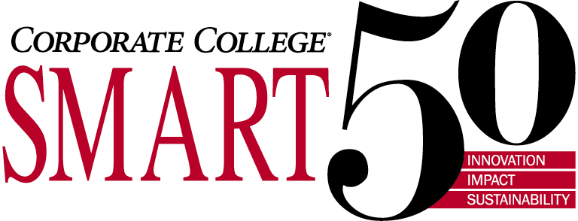

Nexus President and Founding Partner Jeff Herzog Recognized in 2023 Smart 50 Class
Herzog to be Honored Among the Region’s Top Executives in Northeast Ohio

Cleveland, OH, November 16, 2023 – Nexus Engineering Group LLC (Nexus) President and Founding Partner, Jeff Herzog, is to be recognized and honored at the Northeast Ohio Smart 50 Awards 2023.
Since 2014, the Northeast Ohio Smart 50 Awards recognizes the top executives of the 50 smartest companies in the Northeast Ohio region for their ability to effectively build and lead successful organizations. All 50 winners, including Herzog, were honored at a special celebration on Nov. 15.
Creating a "Smart" Organization
In 2005, Herzog founded Nexus Engineering Group with business partner and longtime colleague Marianne Corrao. They wanted to change the way engineering firms serve their clients. After 25 years of working in operating companies and in engineering consulting firms, they saw an opportunity to create an engineering consultancy focused on more than just billable hours and project deliverables. Herzog and Corrao wanted to create a company in which its technical professionals work together with their clients to understand the operational, financial, and business impact of their project work – Nexus calls it Busineering.
More importantly, Herzog and Corrao sought to create a company headquartered in Ohio – their home state – with a work environment and culture that would attract and retain the best engineering, project, and construction talent.
Revenue and Employee Growth
Herzog has been a critical part of Nexus’ growth. The company has doubled its revenue during the last five years, increased its profitability, diversified its base of business, and has a prosperous future ahead.
Nexus is an engineering consultancy that relies on great engineers and project professionals to deliver work to its clients. The company’s team member growth has tracked its sales and revenue performance. The team has doubled its headcount in five years, growing from just shy of 100 team members in 2018 to over 225 professionals today.
The company has a robust mix of chemical, mechanical, electrical, civil engineers and designers, project management professionals, project services, procurement, and construction management specialists. These creative, collaborative, and talented professionals are hyper-focused on making the clients’ problems their own. Clients recognize the breadth and depth of experience and expertise that Nexus provides for a company of its size.
Talent Retention and Professional Development
Even with rapid team growth, Nexus has strong talent retention with average turnover rates between 10 and 15% over the past three years. The company invests in its referral and internship programs with the goal of increasing talent retention over the long term.
The company has invested more than half a million dollars in training and development during the past five years. Efforts include professional development courses through the Case Western Reserve University Executive Education Program, tuition reimbursement for master’s courses, a digital learning platform, as well as incentives for obtaining and maintaining engineering and project management professional licenses.
Nexus has made a conscious effort to invest in its culture by routinely holding team offsites, social events and philanthropic activities, all while championing the passions and interests of its team members. The company’s goal is to celebrate and reinforce attitudes and behaviors aligned to Nexus’ vision of making the company a great place to work. Team members describe the culture as fun, team-oriented, dynamic, challenging, and creative. They also recognize the opportunities that come with the growth the company is experiencing.
Differentiation From the Competition
Nexus is a professional services organization, and its team is what sets them apart from competitors. Delivering great outcomes for clients would not be possible without a connected, collaborative team. The Nexus team works together to produce creative solutions to solve clients’ toughest business and engineering challenges. That is why Nexus clients come back again and again. The firm’s very first client from 2005 is still a client today. This would not be possible without Nexus’ incredible team and the successful culture they have built.
To learn more about Nexus capabilities and team, visit https://nexusegroup.com.

About Nexus Engineering Group LLC

Nexus Engineering Group LLC is a full-service, independent engineering firm headquartered in Cleveland, Ohio with offices in Toledo, Ohio, Midland, Michigan, and Oak Brook, Illinois. Nexus is focused on supporting clients’ specific project goals from concept to startup. Since 2005, clients have recognized Nexus as the engineering services firm of choice in the refining, petroleum midstream, chemical, manufacturing, and utilities industries.

With more than 225 professionals on staff, Nexus is made up of experienced process, instrumentation and controls, structural engineering, electrical, mechanical engineering, and piping professionals with decades of hands-on conceptual and detailed system design, construction, and project management experience.

Nexus delivers project designs that reduce overall risks resulting in safer work environments. By utilizing state-of-the-art software and innovative design tools, Nexus consistently meets client project and investment requirements. Get to know us and you will agree that Nexus is not your typical engineering firm – “Engineering Relationships.”

For more information, visit www.nexusegroup.com

